**Protection of Plants by Insects**

**昆虫对植物的保护**

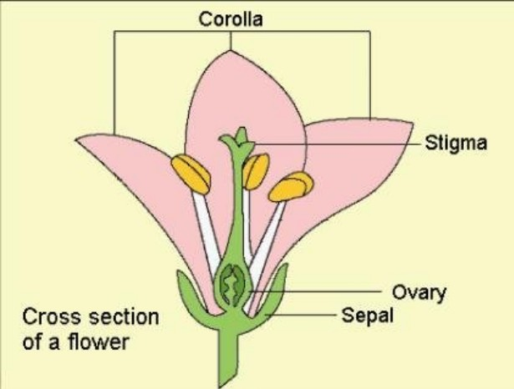

Many plants – one or more species of at least 68 different families – can secrete nectar even when they have no blossoms, because they bear extra floral nectaries (structures that produce nectar) on stems, leaves, leaf stems, or other structures. These plants usually occur where ants are abundant, most in the tropics but some in temperate areas. Among those of northeastern North America are various plums, cherries, roses, hawthorns, poplars, and oaks. Like floral nectar, extrafloral nectar consists mainly of water with a high content of dissolved sugars and, in some plants, small amounts of amino acids. The extrafloral nectaries of some plants are known to attract ants and other insects, but the evolutionary history of most plants with these nectaries is unknown. Nevertheless, most ecologists believe that all extrafloral nectaries attract insects that will defend the plant.

即使不开花，很多植物也能分泌花蜜（在至少68个不同的植物科里就有一种或多种分泌花蜜的植物）。这是因为它们在茎，叶子，叶茎或其他结构上有花外蜜腺（保护花蜜的结构）。这些植物通常生长在大量蚁群存在的地方，因此大多数生长在热带地方，但也有一些生长在温带地区。在北美东北部地区就有这类植物，包括各种各样的李子，樱桃，蔷薇，山楂树，白杨树和橡树。像花蜜一样，花外花蜜主要包括水，高浓度的溶解糖，在某些植物里，还有少量的氨基酸。人们已经知道某些植物的花外蜜腺是为了吸引蚂蚁和昆虫，但是目前大部分带有花外蜜腺的植物的进化史人们还不得而知。尽管如此，大多数生态学家相信所有的花外蜜腺都是为了吸引昆虫以便防御自身。

Ants are probably the most frequent and certainly the most **persistent** defenders of plants. Since the highly active worker ants require a great deal of energy, plants exploit this need by providing extrafloral nectar that supplies ants with abundant energy. To return this favor, ants guard the nectaries, driving away or killing intruding insects that might compete with ants for nectar. Many of these intruders are herbivorous and would eat the leaves of the plants.

蚂蚁或许是植物的最常见也无疑是最执著的保护者了。因为高度活跃的工蚁需要很多能量，而植物正好可以利用这一需求，为蚂蚁提供花外蜜以满足它们的能量需求。为了回报植物，蚂蚁会保卫蜜腺，赶走或杀死入侵的昆虫，因为它们会和蚂蚁争夺蜜腺。很多入侵者是食草动物，会吃掉植物的叶子。

Biologists once thought that secretion of extrafloral nectar has some purely internal physiological function, and that ants provide no benefit whatsoever to the plants that secrete it. This view and the opposing “protectionist” hypothesis that ants defend plants had been disputed for over a hundred years when, in 1910, a **skeptical** William Morton Wheeler commented on the controversy. He called for proof of the protectionist view: that visitations of the ants confer protection on the plants and that in the absence of the insects a much greater number would perish or fail to produce flowers or seeds than when the insects are present. That we now have an abundance of the proof that was called for was established when Barbara Bentley reviewed the relevant evidence in 1977, and since then many more observations and experiments have provided still further proof that ants benefit plants.

生物学家曾经认为分泌花外蜜只产生内部生理功能，蚂蚁对分泌花蜜的植物没有任何益处。人们就该观点及其反方观点争执了很多年。反方观点坚持“保护主义者”假说，认为蚂蚁能够保护植物。1910年，怀疑论者威廉莫尔顿惠勒对这一争议做出了评论。他要求为“保护主义者”观点提供证据：蚂蚁能为植物提供保护；如果没有昆虫，更多植物将会消失，或者不能开花或结种。我们现在已经有充分证据表明昆虫的确有益于植物，因为在1977年巴巴拉宾利就已经研究了相关证据，并且自那以后，更多的观察和实验也提供了更多的证据。

One example shows how ants attracted to extrafloral nectaries protect morning glories against attacking insects. The principal insect enemies of the North American morning glory feed mainly on its flowers or fruits rather than its leaves. Grasshoppers feeding on flowers indirectly block pollination and the production of seeds by destroying the corolla or the stigma, which receives the pollen grains and on which the pollen germinates. Without their colorful corolla, flowers do not attract pollinators and are not fertilized. An adult grasshopper can consume a large corolla, about 2.5 inches long, in an hour. Caterpillars and seed beetles affect seed production directly. Caterpillars **devour** the ovaries, where the seeds are produced, and seed beetle larvae eat seeds as they burrow in developing fruits.

有一个例子向我们展示了被花外蜜腺吸引的蚂蚁如何保护牵牛花不被昆虫伤害的。北美牵牛花的头号天敌昆虫主要吸食牵牛花的花朵和果实而不是叶子。因为草蜢吸食花朵，破坏牵牛花的花冠或柱头，而这正是接收花粉粒和花粉生长的地方，所以间接阻断了授粉和制造种子。一旦花冠被破坏，花朵不能再吸引传份昆虫，因此不能受精。一个成年草蜢可以在不到一个小时消耗一个2.5英寸的大型花冠。相比之下，毛毛虫和象鼻虫则是直接影响种子的形成。毛毛虫毁坏子房，这是生产种子的地方。在果实成熟过程中，象鼻虫的幼虫进入果实内部蚕食种子。

Extrafloral nectaries at the base of each sepal attract several kinds of insects, but 96 percent of them are ants, several different species of them. When buds are still small, less than a quarter of an inch long, the sepal nectaries are already present and producing nectar. They continue to do so as the flower develops and while the fruit matures. Observations leave little doubt that ants protect morning glory flowers and fruits from the combined enemy force of grasshoppers, caterpillars, and seed beetles. Bentley compares the seed production of six plants that grew where there were no ants with that of seventeen plants that were occupied by ants. Unprotected plants bore only 45 seeds per plant, but plants occupied by ants bore 211 seeds per plant. Although ants are not big enough to kill or seriously injure grasshoppers, they drive them away by nipping at their feet. Seed beetles are more **vulnerable** because they are much smaller than grasshoppers. The ants prey on the adult beetles, disturb females as they lay their eggs on developing fruits, and eat many of the eggs they do manage to lay.

每个花萼底部的花外蜜腺可以吸引几种不同的昆虫，不过96%都是蚂蚁，尽管种类会有所不同。当蓓蕾还小时，已经有不到四分之一长的花萼蜜腺分泌花蜜了。随着花朵的发育和果实变得成熟，花萼蜜腺仍然继续分泌花蜜。通过观察可以确定蚂蚁保护牵牛花的花朵和果实不会受到草蜢、毛毛虫和象鼻虫的联合侵袭。宾利对比了六株生长在没有蚂蚁地域的植物结出的果实和17株生长在有蚂蚁地域的植物结出的果实。结果发现：不受蚂蚁保护的植物每株只结出45个种子，而有蚂蚁保护的植物每株结出了211个种子。尽管蚂蚁不够强大，不能杀死或严重伤害草蜢，但是蚂蚁可以通过啃咬草蜢的脚驱赶它们。而比草蜢更小的象鼻虫则更容易受到蚂蚁的攻击。蚂蚁以象鼻虫为食，干扰在果实上产卵的磁性象鼻虫，还能吃掉象鼻虫的卵虫。